Capstone Project

Machine Learning Nanodegree

# Domain Background

The project domain will be the analysis and optimization of traffic light control using machine learning. Efficient ways of organizing traffic light control in an urban environment are important for numerous reasons like lowering fuel consumption, grid lock prevention and overall faster transportation times. Additional challenges include prioritizing traffic dynamically for emergency or police cars or rerouting traffic in case of accidents. Nowadays traffic lights are controlled by static algorithms using time slots. A machine learning approach could potentially optimize traffic. Because traffic lights today are autonomous, unmanaged systems a simulation environment to test a machine learning strategy is necessary.

# Problem Statement

The goal is to develop a reinforcement learning strategy to control traffic lights directly in a simulated environment using SUMO[1]. The following tasks need to be accomplished:

1. Preprocess and analyze the simulation scenarios for the cities of Luxembourg[2] and Cologne[3]
2. Use one or more clustering algorithms to find meaningful clusters for the traffic light controlled intersections
3. Choose and implement a reinforcement learner for each of the clusters which controlls the traffic lights directly using SUMO’s Python interface TraCI[4]
4. Compare the first implementation to random behavior and the scenarios default traffic light algorithms in terms of the aggregates simulation statistics SUMO provides
5. Improve the reward function and re-run the simulations

The reinforcement learner will hopefully improve the overall traffic statistics in terms of total waiting times and fuel consumption.

For a detailed manual of reproducing my results see the Technical HowTo in the project root.

# Evaluation Metrics

The following metrics will be used to evaluate the solution model:

* Duration: average trip duration
* WaitingTime: average time spent standing (involuntarily)
* TimeLoss: average time lost due to driving slower than desired
* DepartDelay: average time vehicle departures were delayed due to lack of road space
* Emergency Stops: The number of emergency stops card had to make

They are provided by the simulation and are directly related to the overall efficiency of the traffic system.

# Clustering Analysis

## Introduction

The full clustering analysis can be seen in the Jupyter Notebook clustering_code/clustering.ipynb file. I decided to run the clustering analyses on three datasets:

1. The TAPAS Cologne (cgn) dataset
2. The LuST (lust) Datasets
3. A combination of the two

The idea behind this approach was to see if the different scenarios would have similar clustering results and to get a deeper understanding of SUMO scenarios. Additionally, it was interesting to see if a combined dataset would benefit from including more data.

## Importing the Data

Before clustering could be implemented, the dataset needed to be converted into a pandas dataframe. The following values are collected:

* junction_id: the id of the intersection
* junction_type: is always traffic_light[5]
* x,y,z: the physical coordinates of the junction in the simulations
* isRoundabout: Whether the intersection is part of a roundabout
* trafficlight_count: an array containing the number of traffic lights the intersection controlls, the trafficlight’s ID and a list of all the connections to the intersection
* avg_lane_speed,avg_lane_length& standard deviations: Because every intersection has a different amount of lanes, the mean was used to aggregate their speed limits and lengths. To mitigate the information loss the standard deviation was also computed.
* edge_types: the different types of edges[6] connected to this intersection
* edge_priorities: The average of the edge’s priorities. Because these values are very close together, the standard deviation was not included
* number of lanes: the total amount of lanes in the junction

The script that generates csv files for scenario files can be found in the “clustering_code/dataset-import.py” file[7].

## Preprocessing the Datasets

A few columns had to be dropped or reformated. For example, initially I included the x,y and z coordinates in the clustering process. The idea was that maybe intersections that are nearby each other in a geographical sense, could be similar. Due to later analyses I decided to exclude them.

The isRoundabout was converted from {true|false} to {0|1}. One more challenging tasks was to convert the different edge types. I used sklearn’s MultiLabelBinarizer(MLB) to accomplish this task. Also it was interesting to run the clustering analyses with and without the MLB to see how much of an impact the types would have[8]. Including the MLB-generated values resulted in different results for the datasets. For the cgn dataset including the types resulted in more or the same amount of clusters depending on the algorithm. For the lust dataset it resulted in more or the same clusters with one exception where it reduced the amount of clusters. Finally, I decided to include the MLB because the amount of traffic lights controlled where better distributed among the clusters. Without the MLB sometimes one cluster would include above 90% of all intersections with n-traffic lights and the other m-clusters would include only one intersection.

## Feature Scaling

## Dimensionality Reduction using PCA

## Clustering using the Silhouette Score

Silhouette score[9]

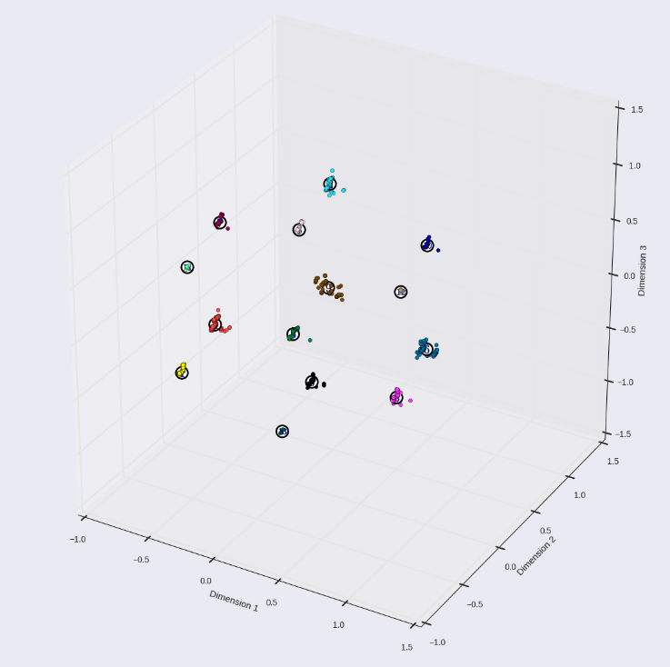  
Illustration 1: cgn-dataset with max_abs scaler and 3 Dimension PCA

## Analysis of Clustering Results

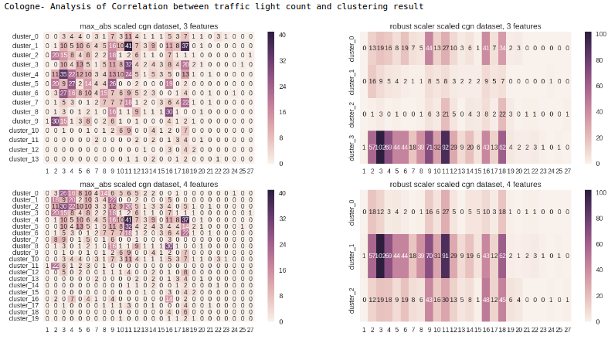

## Conclusion of Cluster Analysis

## Data Export

As a last step the cluster ids for the different algorithms had to be appended to the original dataset. The notebook creates the necessary csv files for the next phase of the project.

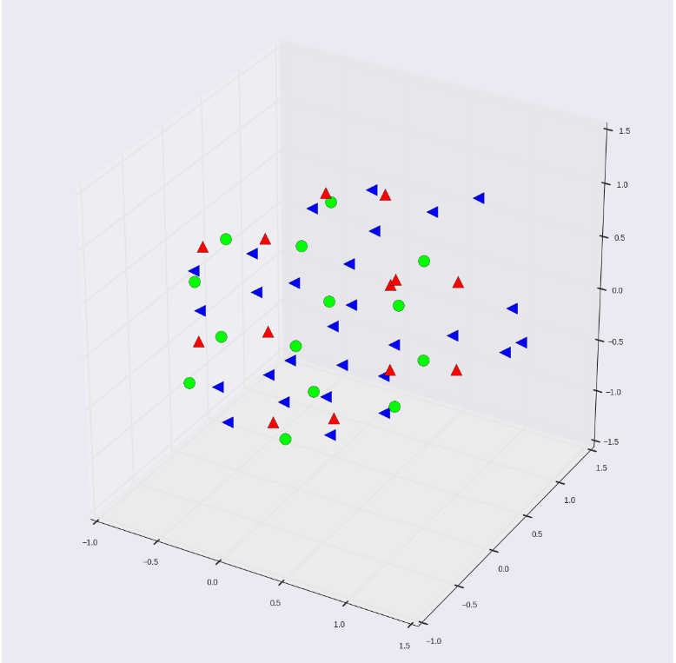  
Illustration 2: green=cgn, red=lust, blue=combined, max_abs scaled, 3 dimension PCA, center comparison

# Traffic Light Control

# Algorithms and techniques

Initially I wanted to use the PyBrain[10] library to solve the problem. The first boundary was that the PyBrain RL learner could only handle discrete state spaces. One solution to deal with that I came up with was to use intervals for the relevant simulation statistics to discretize them. For example, for the waiting time statistic I would have mapped 0 to “very good”, 1-5 to “ok” and everything above 5 to “bad”. I could have based the intervals on statistical analyses of a full simulation run.

Although this would have worked, I found out about Deep Reinforcement Learning during my research[11] [12] [13].

Finally I preferred use this implementation of DQN[14].

## Benchmark

For benchmarking my implementations I compared them to the aggregated statistics of random behavior to see if my learner had actually learned something. In addition I ran the simulations with their own traffic light control algorithms to see if my model could improve the statistics.

# Methodology

Preparing steps

implementations

refinement

# Reflection

The most difficult parts of the project were:

1. Choosing the right RL algorithm&implementation has proven to be quite difficult but incredibly interesting.
2. Initially I did not suspect the large action spaces. Due to the larger intersections with over 20 traffic lights, and each light having at least 5 different reasonable states, action spaces quickly became to large to handle.
3. Building a good reward function was very difficult. I did not want to introduce too much bias and TraCI does not provide aggregated simulation statistics or warnings during simulations. These values could have proven helpful.
4. Simulation runs took a very long time because of the computational intensive nature of the project. I bought a new GPU for using CUDA and ran simulations mostly overnight.

Although the final result is not an optimal traffic light controller, I learned a lot about reinforcement learning during the project.

# Improvement

There are numerous ways I’d like to improve the project that were out of scope.

* The problem of a large action space needs to be addressed. I was already thinking about moving the learner to a continuous action space- implementation comparable to the one proposed in this paper[15] and map the actions into a continuous domain. Maybe there are other interesting techniques for large discrete action spaces.
* TraCI needs to be enhanced. Getting emergency stops and aggregated statistics in real time would be very helpful
* Because a lot of computational power is needed, the code should be moved to the cloud for faster evaluation
* Some meaningful visualization[16] of the high dimensional deep learning neural net to better understand the Q-function could be found

1. www.sumo.dlr.de
2. https://github.com/lcodeca/LuSTScenario
3. http://sumo.dlr.de/wiki/Data/Scenarios/TAPASCologne
4. http://sumo.dlr.de/wiki/TraCI
5. Initially it was planned to incorporate different junction types in the clustering analysis and there was more than one type in the dataset
6. An example from TAPAS Cologne dataset: ['highway.primary', 'highway.primary', 'highway.residential']
7. A few steps need to be executed before running the importer, they are documented in the comments
8. See MLB-NoMLB-comparison.docx for more details
9. http://scikit-learn.org/stable/modules/generated/sklearn.metrics.silhouette_score.html
10. http://pybrain.org/
11. https://oshearesearch.com/index.php/2016/06/14/kerlym-a-deep-reinforcement-learning-toolbox-in-keras/
12. https://github.com/matthiasplappert/keras-rl
13. https://homes.cs.washington.edu/~todorov/courses/amath579/reading/Continuous.pdf
14. https://jaromiru.com/2016/10/03/lets-make-a-dqn-implementation/
15. https://arxiv.org/abs/1509.02971
16. http://heatmapping.org/